STEP 2 – File generation for Theater Landclass
2.0-) Open the file raw.bil on GM.
2.1-) It is time to generate the files for LANDCLASS. Save the BMP image of the map:
FILE – EXPORT – EXPORT RASTER / IMAGE FORMAT… Select BMP Export Format
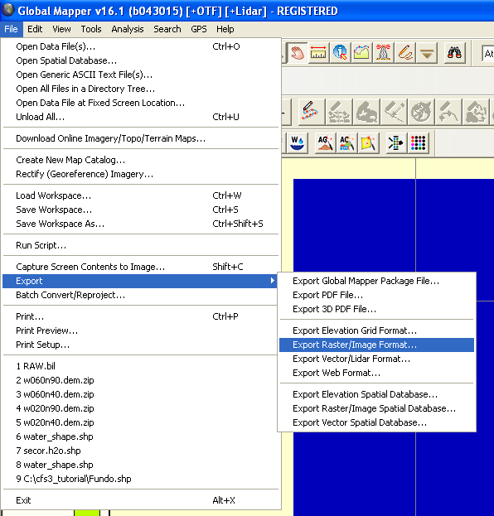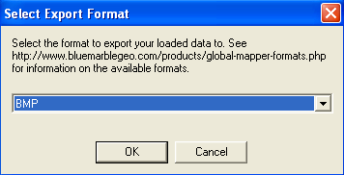

Do not change any parameters on Export parameters window, just click OK. Save the image like LC.bmp on your working dir. It’s a intermediate file.

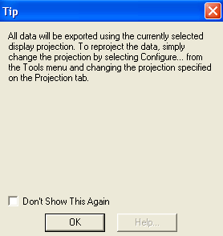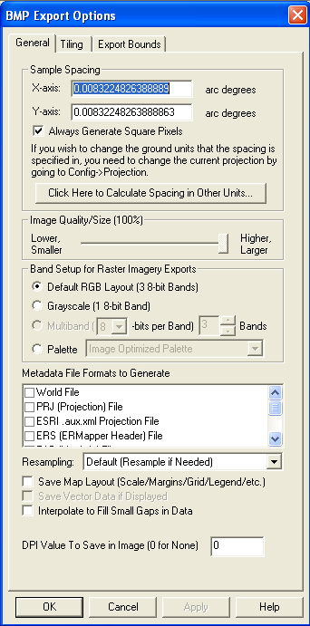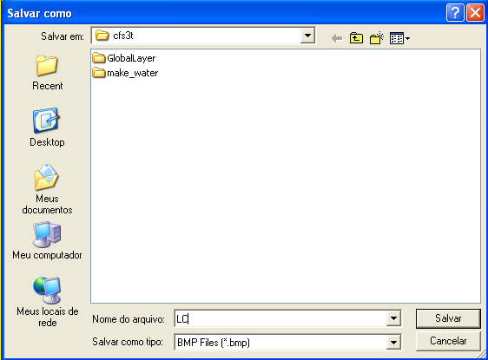
TIP- The bitmap generated have the same size of raw.bil file : 768x768
2.2-) Close the GM. Do not save any modification.
2.3-) Open PHOTOSHOP and open the LC.bmp file.
2.4-) Map painting with the c2v.txt colors. For this tutorial, I used only 2 landclass colors:
Index 0 – RGB – 0,0,255 (blue)
Index 6 – RGB – 0,255,0 (green)
A-) With MAGIC WAND TOOL (shortcut keyboard – W) enabled, to use the indicated parameters. Click on any point in the ocean color area. The selection must be like the following image.
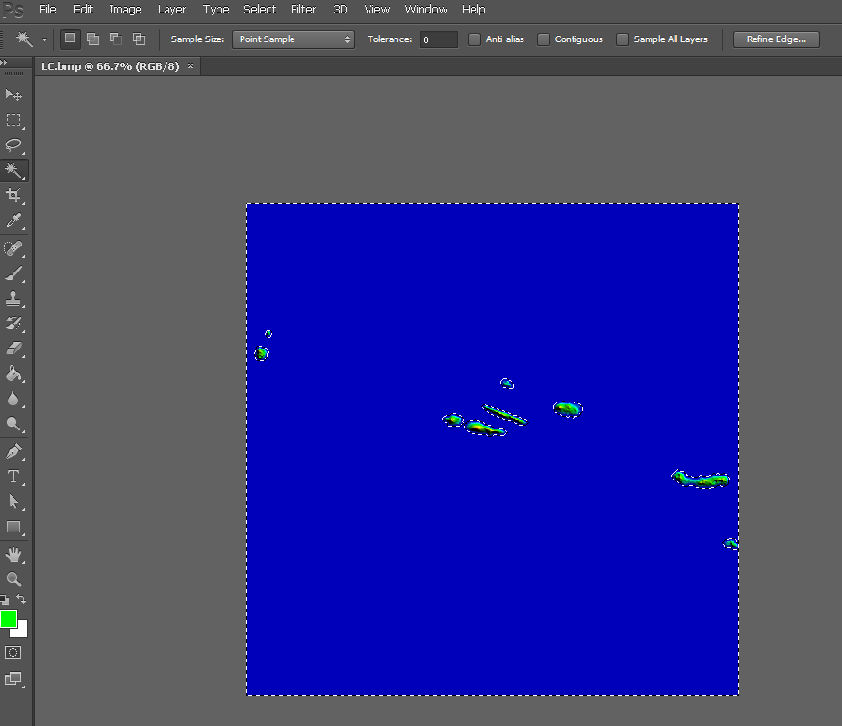
Background color
Magic wand tool
B-) Delete selection area color pressing DELETE on Keyboard. Use the background color (White).
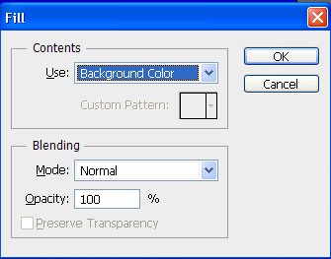
C-) Select the 1st color on Color Picker window by pressing the FOREGROUND COLOR on left toolbar or in Color Tab on right. Edit RGB text boxes like following image (0,0,255). Click OK.
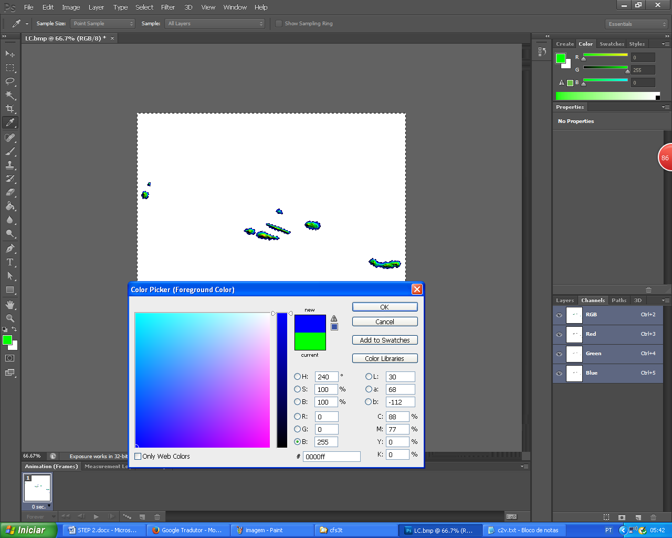
D-) With the correct landclass color selected, choose the PAINT BUCKET TOOL and apply into selection area. The 1st color is applied.
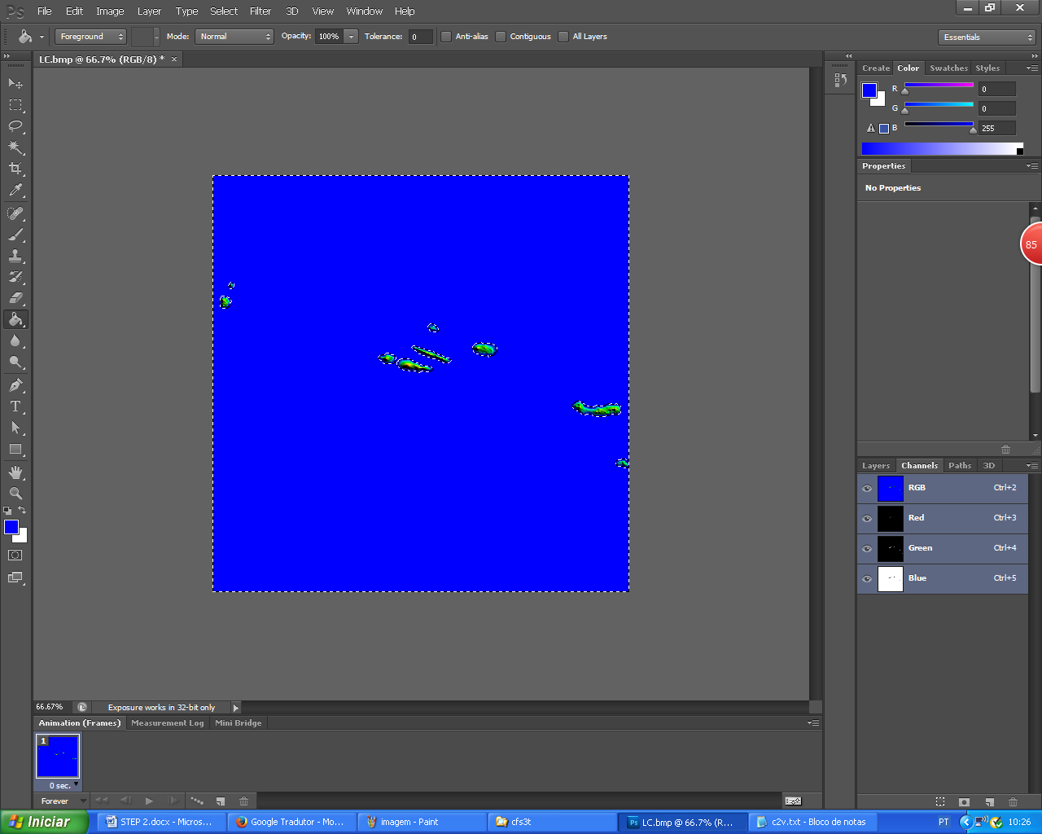
E-)The same procedure for the 2nd color, but first, inverse the selection: SELECT – INVERSE
Now, only islands are selected.
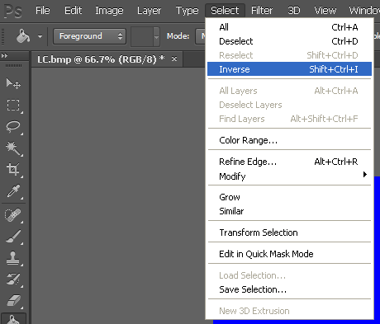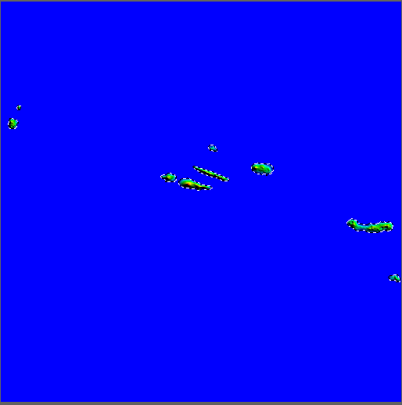

F-) Delete the selected area with DELETE keyboard key. Use the background color (White).
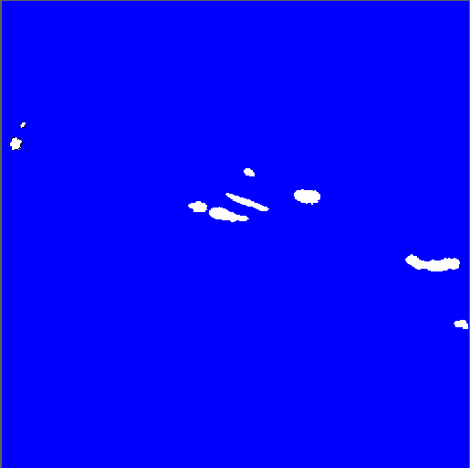
G-) Select the 2nd color on Color Picker window by pressing the FOREGROUND COLOR on left toolbar or in Color Tab on right. Edit RGB text boxes like following image (0,255,0). Click OK.
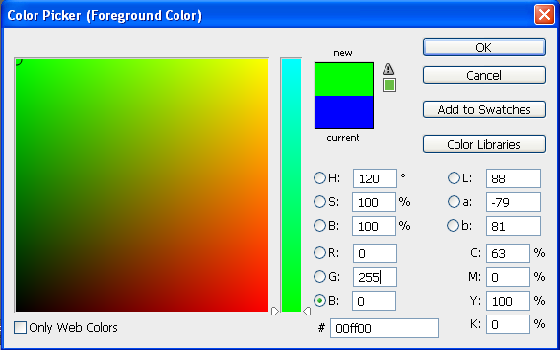
H-) With the 2nd landclass color selected, choose the PAINT BUCKET TOOL and apply into selection area. The 2nd color is applied.
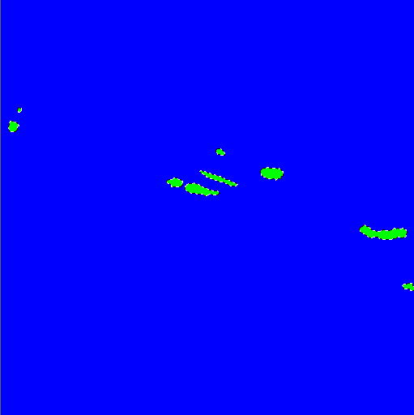
I-) For the next step, lets deselect all: SELECT - DESELECT
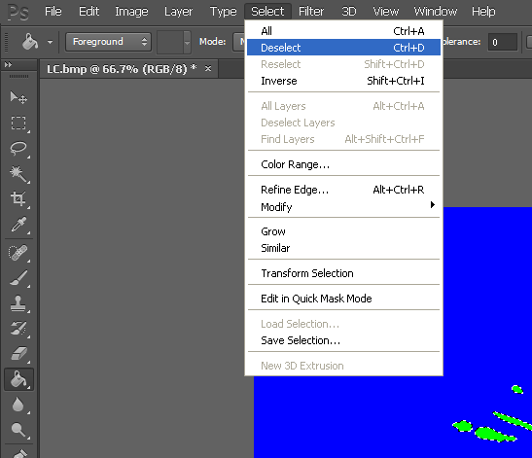
TIP – Note that this image do not have transitions colors between blue and green. Its required for the SDK tool. If you will paint the image with all landclass colors, use one layer for each color and merge all layers at the final work.

J-) The file for landclass tool need an ALPHA CHANNEL. Let´s do it: SELECT – ALL
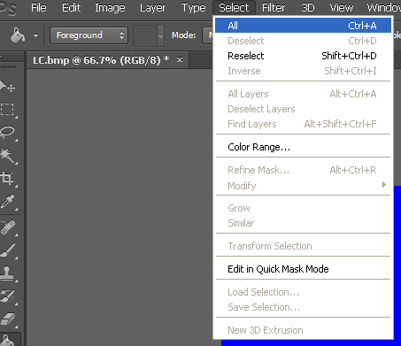

L-) SELECT – SAVE SELECTION… Parameters like following image. Just click OK.
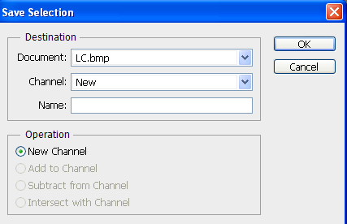
M-) If you are seeing the new channel at lower right tab, it´s time to save the modifications on new TIFF file.
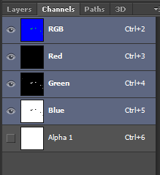

N-) Check some parameters before save: IMAGE – MODE
RGB Color – Selected
8 Bits/Chanel – Selected
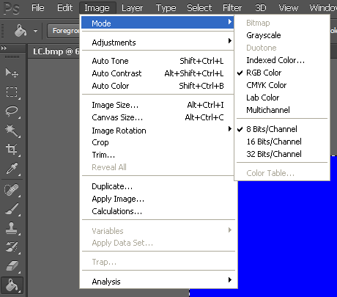
O-) Save a new TIFF file: FILE – SAVE AS…
Keep the TIFF options like following image.
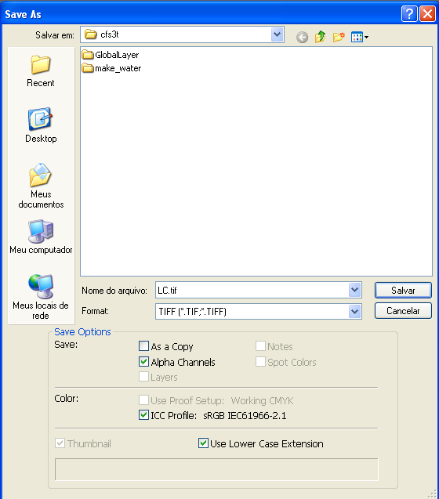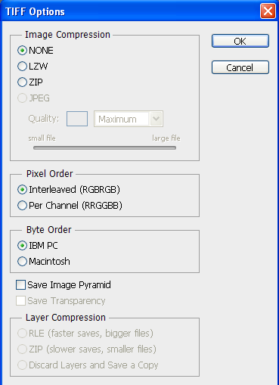

2.5-) Close the Photoshop. If you want, delete the LC. bmp file. KEEP THE LC.tif.
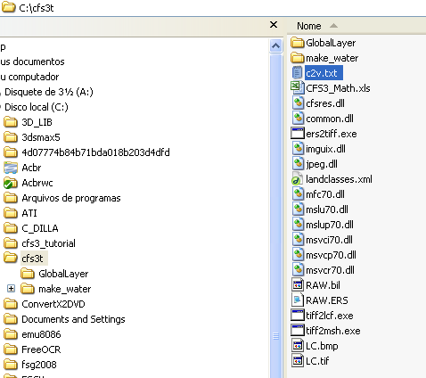

2.6-) END OF STEP 2

